7.47: a) Use work-energy relation to find the kinetic energy of the wood as it enters the rough bottom: 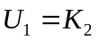 gives 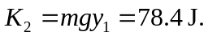
Now apply work-energy relation to the motion along the rough bottom:
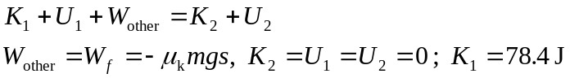
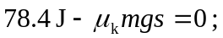 solving for s gives 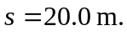
The wood stops after traveling 20.0 m along the rough bottom.
b) Friction does 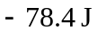 of work.

